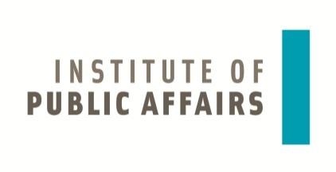

Centre for Public Policy PROVIDUS and Institute of Public Affairs are pleased to invite you to the seminar

Poland, Latvia, Lithuania and Estonia:
cooperation and outlooks in the context of regional and EU challenges

on 25th November 2015, 10.30 AM at the European Union House in Riga (Aspazijas bulv. 28, 2nd floor)

The Institute of Public Affairs conducted polls in Poland, Latvia, Lithuania and Estonia on opinions in the four societies on current international and regional affairs. What are the most significant results of these polls with regard to mutual relations between the four countries, impact of EU integration, Russian-Ukrainian conflict, NATO bases and accepting refugees? To present the study and discuss the main challenges faced by our region and the European Union in international affairs the event will gather prominent experts from the four countries. In the context of the Polish Presidency in the Council of the Baltic Sea States the debates will also focus on cooperation between the four countries.

10:30 – 10:35 Opening
Dace Akule, PROVIDUS

10:35 – 10:50 Introductory remarks
Polish-Baltic cooperation in the context of the Polish Presidency in the Council of the Baltic Sea States 2015-16
Ewa Dębska, Ambassador of the Republic of Poland

10:50 – 11:30 Presentation of results of opinion polls
Agnieszka Łada, Institute of Public Affairs

11:30 – 11:45 Coffee break

11:45 – 13:30 Debate
What conclusions come from the opinion polls for the regional cooperation? How to strengthen regional cooperation in reaction to current developments in the East and in the European Union? Is a refugee crisis a security challenge and what should be the regional reaction? How the Council of the Baltic Sea States can reinforce regional cooperation?

Justyna Frelak, Institute of Public Affairs (Poland)
Maria Golubeva, PROVIDUS (Latvia)
Helga Kalm, International Centre for Defence and Security (Estonia)
Greta Monika Tuckute, Centre for Geopolitical Studies (Lithuania) tbc

Moderator: Dace Akule, PROVIDUS

The debate will be held in English without translation

The project is co-financed by the Ministry of Foreign Affairs of the Republic of Poland in the framework of the programme “Cooperation in the area of public diplomacy 2015”. The project is co-financed by the PZU Foundation.
